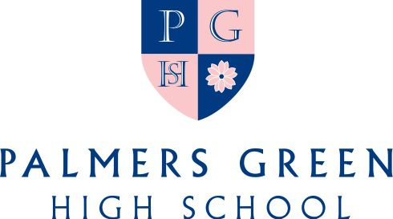

ADMISSIONS PROCESS FOR ENTRY INTO PGHS – SEPTEMBER 2021

ENTRY INTO RECEPTION IN SEPTEMBER 2021

Deadline for Registrations – 31st December 2020

Reception Assessments – These are planned to take place in early February 2021

Reception Assessment Results - Letters will be posted and emailed to all parents after assessments have taken place with information regarding the outcome of their daughter’s application to join the School.

Acceptance date for offer of a place – Two weeks from the date of the offer letter.

ENTRY INTO YEAR 7 IN SEPTEMBER 2021

Deadline for Registrations – 31st December 2020

11+ Entrance & Scholarship Exam - Saturday 16th January 2021

Invitation to Interview - Planned for late January/early February 2021
Girls who have performed well in the entrance tests will be invited to attend an interview. Part of the interview is a short presentation on a subject of your daughter’s choice. Previous presentations have included hobbies, interests such as music or sport, a special holiday or event. You will be contacted by the School Office by telephone regarding your interview date and time.

Financial Assistance - Parents who have applied for bursaries will be invited to attend an interview with the Bursar, normally on the same day as their daughter’s interview with the Headmistress.

Music Awards - Wherever possible, candidates for music awards will be invited for their audition on the same day as their interview.

11+ Results - Letters will be posted and emailed to all parents after the interviews have taken place in early February with information regarding the outcome of their daughter’s application to join the School.

Acceptance date for offer of a place – Wednesday 3rd March 2021

If you have any queries, please do not hesitate to contact the School Office.

