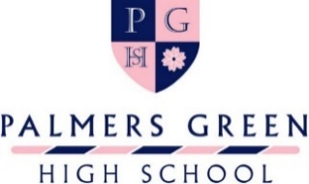

11+ ART SCHOLARSHIP APPLICATION FORM
Before completing this form, please read the Art Scholarship information document that explains the full assessment process and the expectations of an award holder.
Please complete and return this form to Admissions on office@pghs.co.uk by Tuesday 1st November 2022.
Interviews will be held in November and December 2022.
Daughter’s Name
Current School
The table below is for you to detail your daughter’s interest and achievements in Art. Please do not be overly concerned if some of the rows remain blank, we are very aware that available experience differs widely between schools.
Please detail all relevant clubs and events related to Art that your daughter has participated in outside of school over the last two years.

Please give details of any Art competitions that your daughter has participated in and note the success/recognition achieved over the last two years.

Please give details of any Art festivals your daughter has participated in over the last two years.

Please list any holiday Art courses your daughter has attended over the last two years.

Please give details here of your daughter’s particular interests in Art.

Please add here any other information that you feel is relevant to this application (for example, a recent visit to an exhibition or gallery).

Portfolio
Your daughter is required to submit a digital portfolio of work to the Head of Art by Tuesday 1st November 2022. The portfolio should include between five and ten pieces of artwork that show a variety of media and which have been completed in the last 2 years.

The portfolio should be submitted in a single file, for example, as a PowerPoint presentation or PDF and emailed to office@pghs.co.uk. Please ensure that all images are of good quality and ideally presented on a white background. A ruler should be added to the image to indicate the scale.

With your Application Form, please enclose a short reference from an Art teacher, either from school or an outside Art group.
Parent Name
Parent Signature

