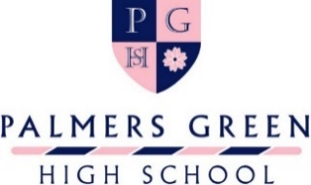
11+ MUSIC SCHOLARSHIP APPLICATION FORM
Before completing this form, please read the Music Scholarship information and note that candidates must have reached a standard equivalent to Grade 4 or above of a recognised examining body.
Please complete and return this form to Admissions on office@pghs.co.uk by Tuesday 1st November 2022.
Auditions will be held in November and December 2022.
Daughter’s Name
Current School
The table below is for you to detail your daughter’s interest and achievements in Music. Please do not be overly concerned if some of the rows remain blank, we are very aware that available experience differs widely between schools.
Instrument(s) played (including voice) | Length of time studied |  | Level of achievement
Please detail all music groups, such as choirs, orchestra and ensembles, that your daughter has been involved in at their current school over the last two years.

Please give details of any music groups that your daughter has attended on a regular/weekly basis outside of school over the last two years.

Please list results from any formal examinations, including theory, in Music over the last two years.

Please give details of any Music festivals or competitions that your daughter has participated in over the last two years.

Please list any holiday Music courses that your daughter has attended over the last two years.

Please add here any other information that you feel is relevant to this application. (for example, a recent visit to concert).

Supporting Statement
Your daughter is required to submit a supporting statement, of no more than 500 words, outlining why they should be considered for a Music Scholarship. This should be submitted by email to office@pghs.co.uk for the attention of the Head of Music by Tuesday 1st November 2022.

With your Application Form, please enclose a short reference from a Music teacher, either from school or an outside Music group.
Parent Name
Parent Signature

